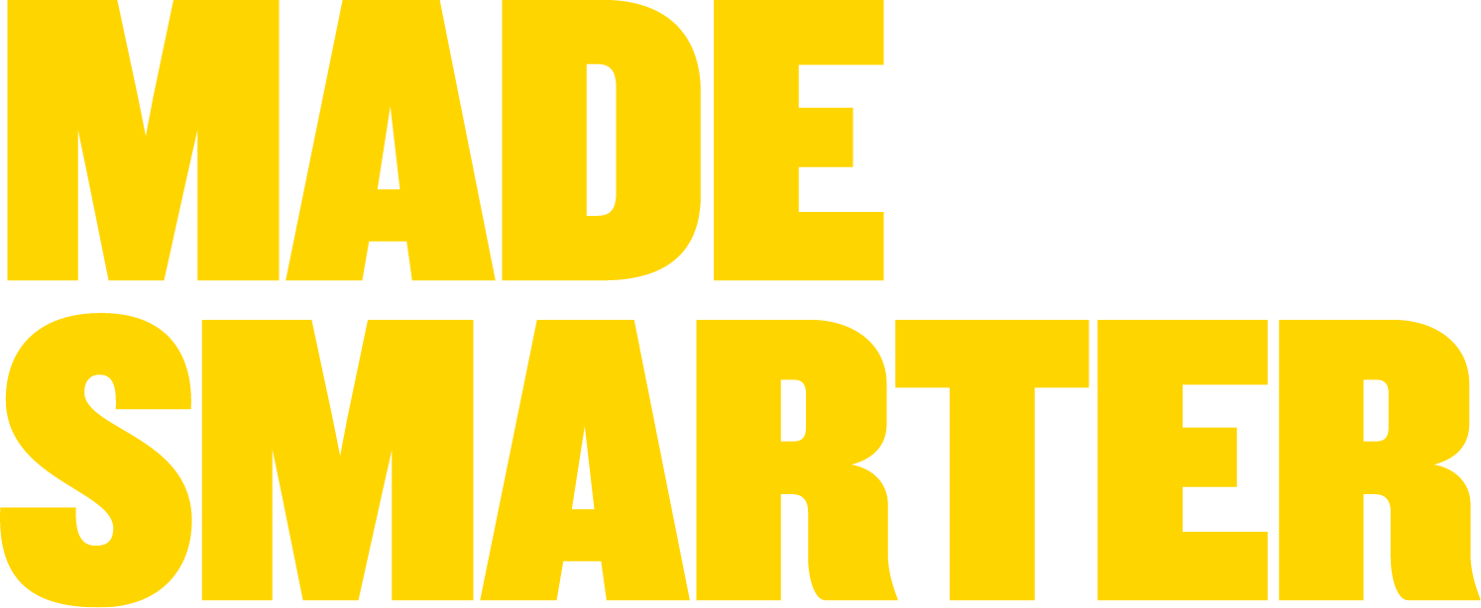

Digital Technology Internship Placement

Employer Information:

‘Made Smarter’ is a Government funded programme, matching your expertise, skills, and insight to help North West businesses implement digital tools. You will be working on a live project while gaining valuable experience for your C.V.
Placements are open to 3rd and 4th Year Undergrads, MSc, and Postgraduate Students

Placement Information

Job Title: | Application Engineer - Sensor/IOT design  Reference: 27611Z
Business Overview | Our client is a micro company based in Wirral, working on health care sector devices and apps to enable remote patient diagnosis and to improve the ongoing management of health issues by improving the ability to take information remotely without people having to go to GP or hospital to take this information on a regular basis.  The market for these devices includes the NHS through primary and secondary care providers.
Location: | Wirral, CH47 3BB
Number of posts: | ONE
Job Description/Project Overview: | Virtual Remote Access Home Visit System  An exciting project to take a proof of concept device and application to a fully working prototype to enable controlled environment user testing & validation.  Following a Project Overview briefing and a Detailed Design briefing from the Project Team (including a Medical IT specialist), the key tasks will be:  - Work Up a Functional Design Specification  - Work Up a Detailed Design Specification including IT System architecture  - Data Interface Programming using C++  - Sensor Design  You will review the existing proof of concept device and application and then create a working prototype for review. You will also create a plan to take the prototype into production. Considerations will need to include final unit design, maintenance, service and robustness.  Typical Duties will involve:  Sensor Specification for the device: Blood Pressure and Blood Sugar in addition to the four pathologies already achieved (Body temperature, ECG, heart rate, oxygen levels in various areas of the body)  Application, IOT Design, Interface Programming to enable data transfer from sensor to the cloud.  Data App Dashboard design – to a specification set out by Medical Practitioners  The work plan: part time over 6 month period:  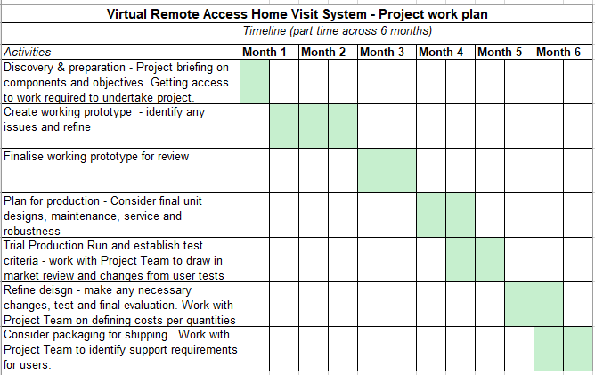
Expected areas of knowledge: | Essential:  - Programming, C++  - PHP 7 and MYSQL (open-source relational database management system)  - Knowledge of creating a user-friendly web access front end  - Pro-active, independent learner with an aptitude for problem solving  - Good communication skills  Desirable:  - Experience in creating user-friendly web access front end applications  - Experience in developing systems using sensors  - Production knowledge  - Project Management experience
Salary: | £12.00 p/h (£5,760 per placement)
How to apply: | By e.mail to Amanda Lyons, Made Smarter DTI Placement Manager at: amanda.lyons@growthco.uk
Placement Start Date: | Oct 2021
Duration of Placement: | 480 Hours on a full-time, part-time, or flexible schedule
Additional Info: | You will be required to register your interest in a Digital Technology Internship with Made Smarter on our website at: www.madesmarter.uk  C.V’s can be uploaded at the point of registration or forwarded directly. Your details will be stored to allow us to contact you for any future suitable opportunities.

