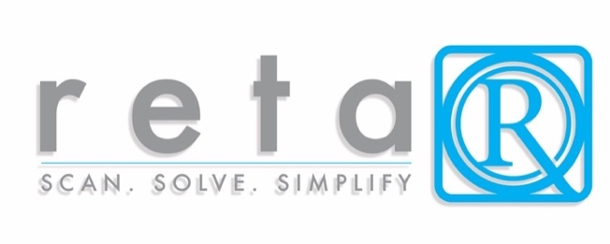

Reta QR x Made Smarter: Supporting Manufacturers Through Smart Post-Sale Innovation

Introduction
Reta QR is a cutting-edge post-sale support platform that transforms how customers interact with physical products by delivering intelligent, on-demand help through a simple QR code. As the UK manufacturing sector embraces Industry 4.0 and Made Smarter principles, Reta QR offers a practical, scalable solution for manufacturers looking to digitise support, improve customer satisfaction, and reduce costs.

How Reta QR Supports Manufacturers

1. Enhancing the Customer Experience
- Offer instant access to how-to-build videos, e-manuals, and setup guides via QR codes
- Reduce confusion and frustration with easy-to-follow, mobile-first support content
- Increase customer satisfaction and reduce post-purchase regret

2. Reducing Support Costs & Product Returns
- AI chatbot answers customer queries instantly, reducing the burden on call centres
- Improved understanding and guidance lead to fewer returns, repairs, and complaints
- Streamlined customer support for setup-heavy or self-assembly products

3. Enabling Smarter, Sustainable Products
- Eliminate paper manuals with digital alternatives, contributing to sustainability goals
- Update support content in real-time without reprinting or repackaging
- Capture engagement data to continuously improve product support and design

4. Empowering Data-Driven Decisions
- Detailed analytics on user interactions, FAQ trends, and product performance
- Identify recurring issues or parts confusion using AI keyword flagging
- Feed insights into product design, packaging, and user experience improvements

Aligned with Made Smarter Goals
Reta QR supports the Made Smarter mission by:
- Digitising customer-facing processes with innovative, scalable solutions
- Enabling manufacturers to adopt digital tools without disrupting core operations
- Reducing waste through e-manuals and more efficient support
- Empowering small to medium manufacturers to compete with enhanced customer experience

Ideal Use Cases
- Flat-pack furniture, home and garden equipment
- Fitness gear, bicycles, DIY products
- Consumer electronics and appliances
- Children’s toys and safety products

Conclusion
Reta QR helps UK manufacturers modernise product support, reduce costs, and deliver better post-sale experiences—all without adding complexity to their operations. It’s a simple, powerful way to stay competitive in a digital-first economy.
Contact us to learn how Reta QR can integrate with your product line and support your Made Smarter transformation.

